
Saad Mughal
F2023-009
Total Marks: 10
Due 02 March 2026

Computer Networks LAB

Week 4

TCP Client Server Communication

Course Lecturer: Shaiza Rizwan
Lab Instructor: Hasnain Ahmad
Section: C

Computer Networks LAB (LAB-209) - Lab 03
Socket Programming: TCP Client Server Communication

Task 1
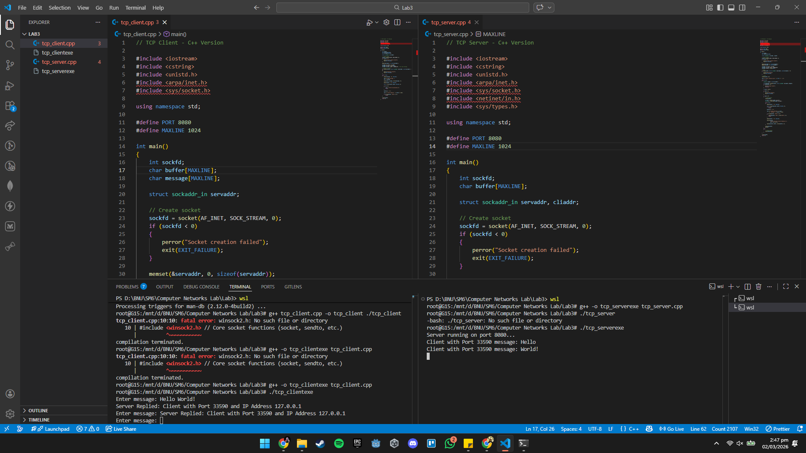

Task 2
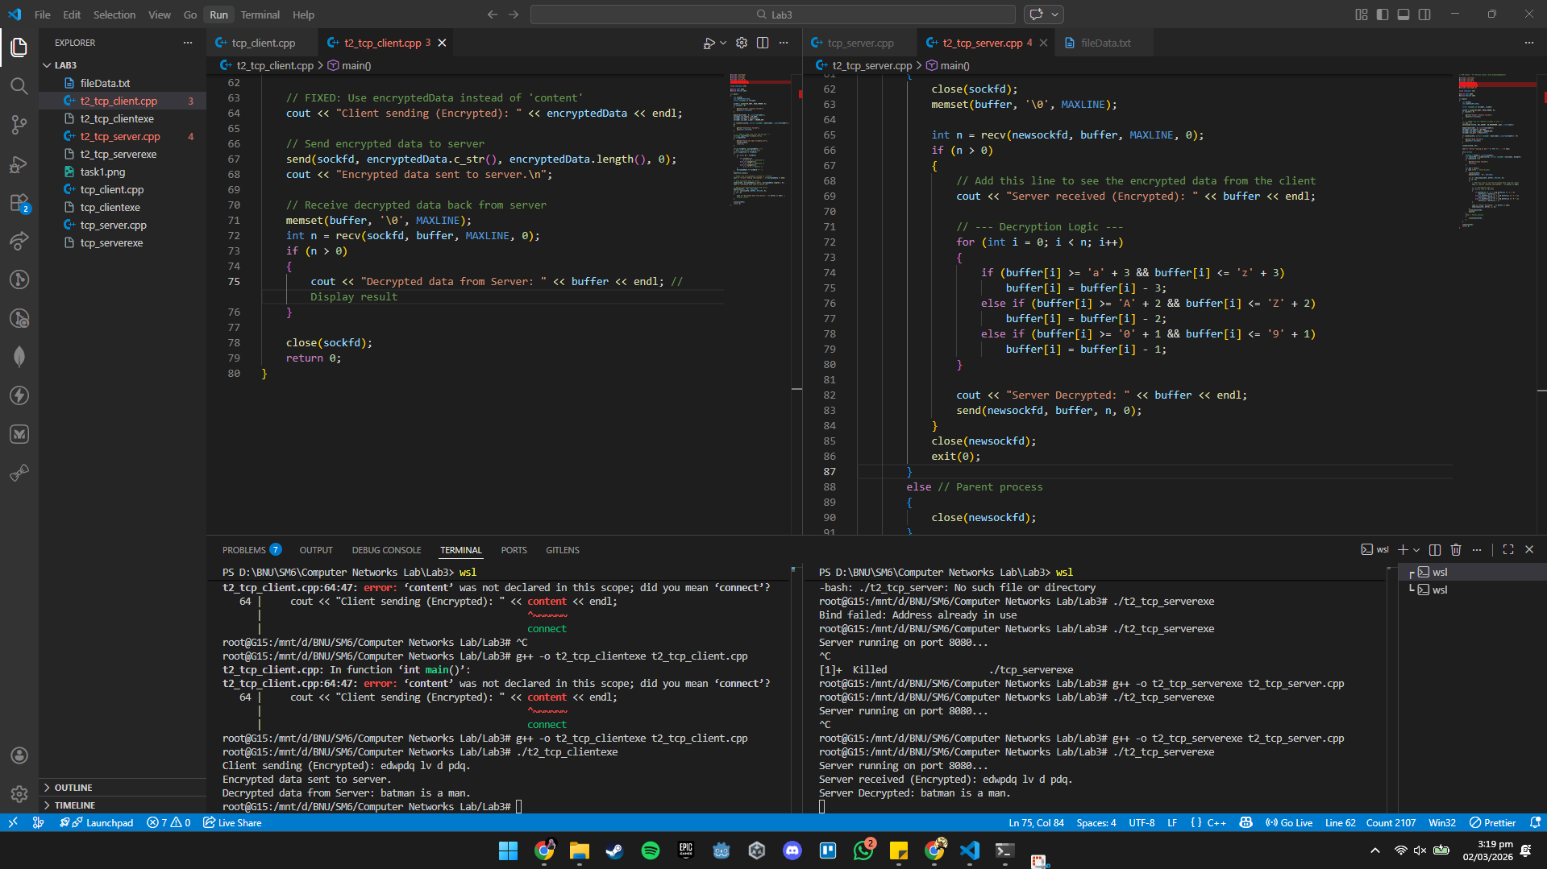

Task 3
